Photos for QL 4

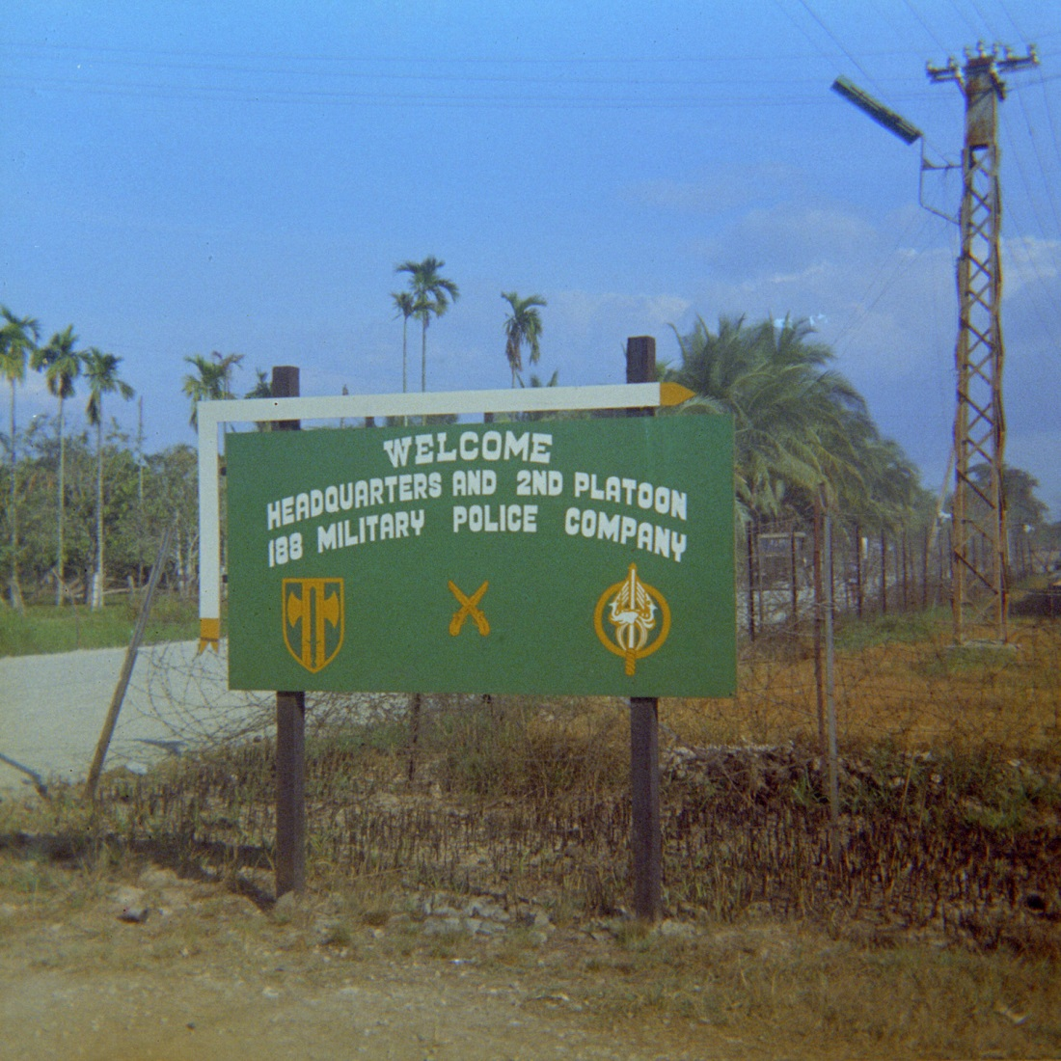

586959_1.jpg

The entrance to the MP compound outside Vinh Long in December 1969, before completion of the sandbag fortifications and bunkers. The “MP villa” in QL 4 is based on this compound, although the book’s version is different in some respects. The crossed pistols are the insignia for the U.S. Army Military Police and the shield to the left represents the 18th MP Brigade, which included the company spread among several locations in the Mekong Delta (Vinh Long, Can Tho, My Tho, and Soc Trang).

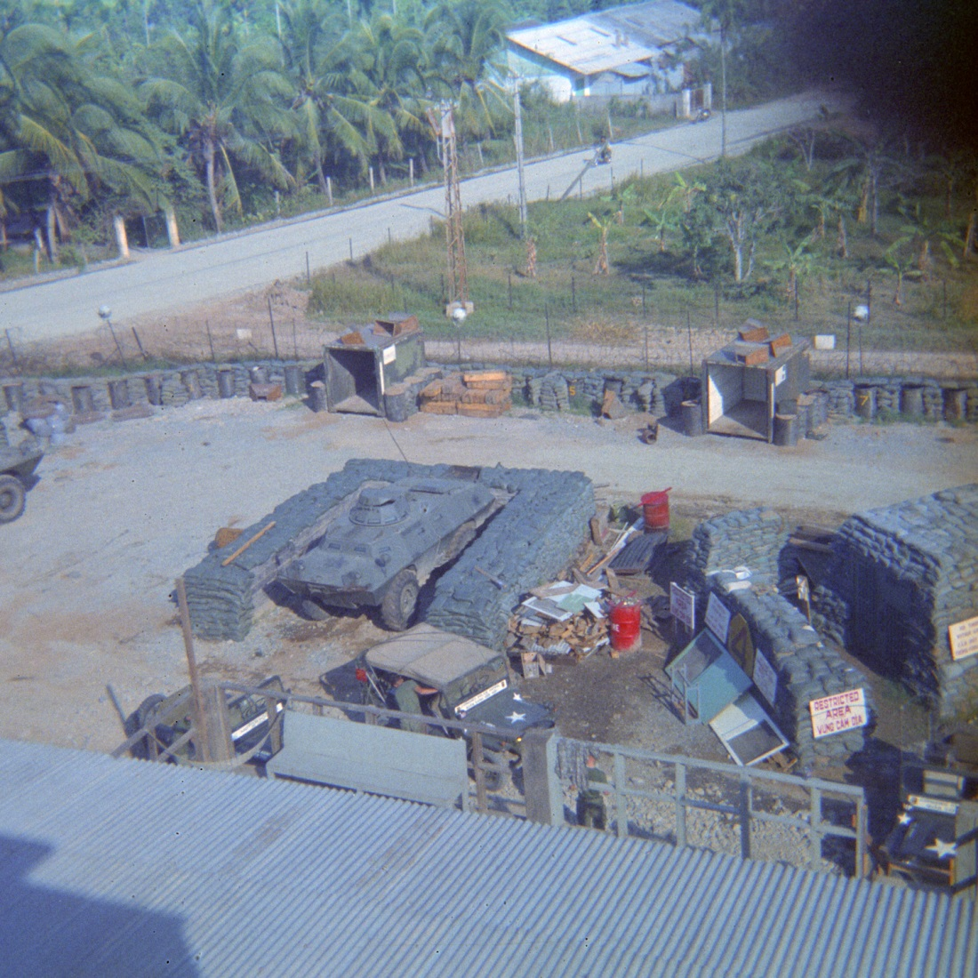
586959_6.jpg

A view of the compound from the roof of the “MP villa.” Note the road to the canal, the perimeter and bunkers under construction, and a V-100 armored car in a revetment. The V-100 had a turret with twin .30 caliber machine guns.

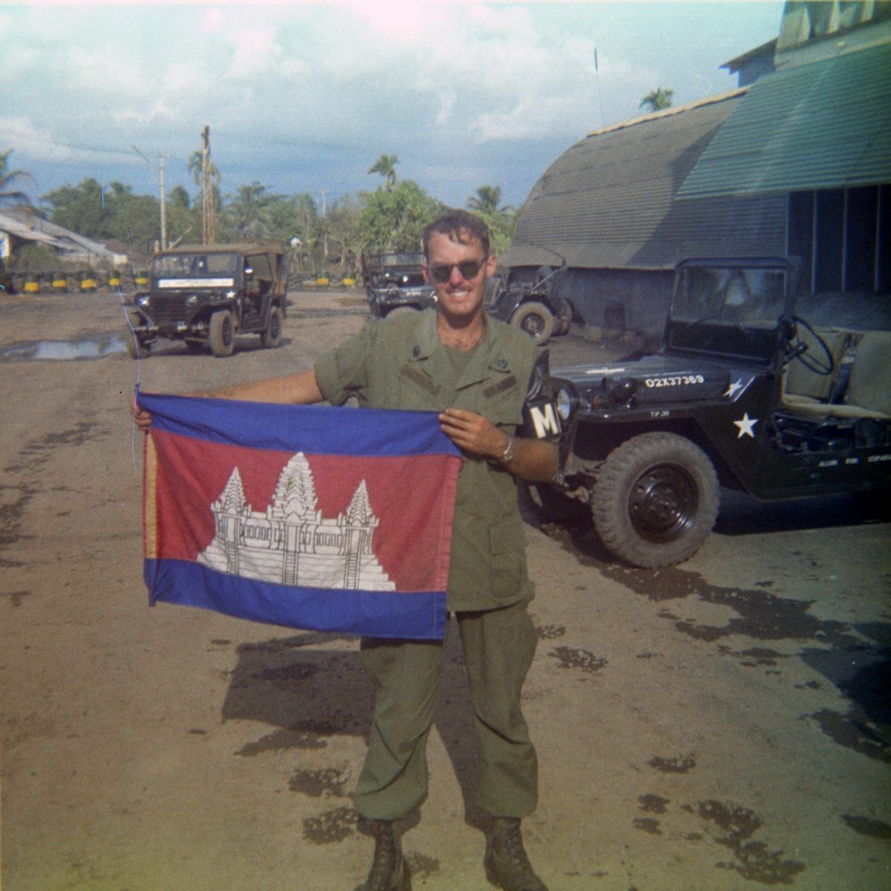
362770_5A.jpg
Inside the compound, the author with a Cambodian flag following the invasion of Cambodia in May 1970. The flag prop was provided by a returning ARVN (Army of the Republic of Vietnam) soldier at the cost of a case of beer.
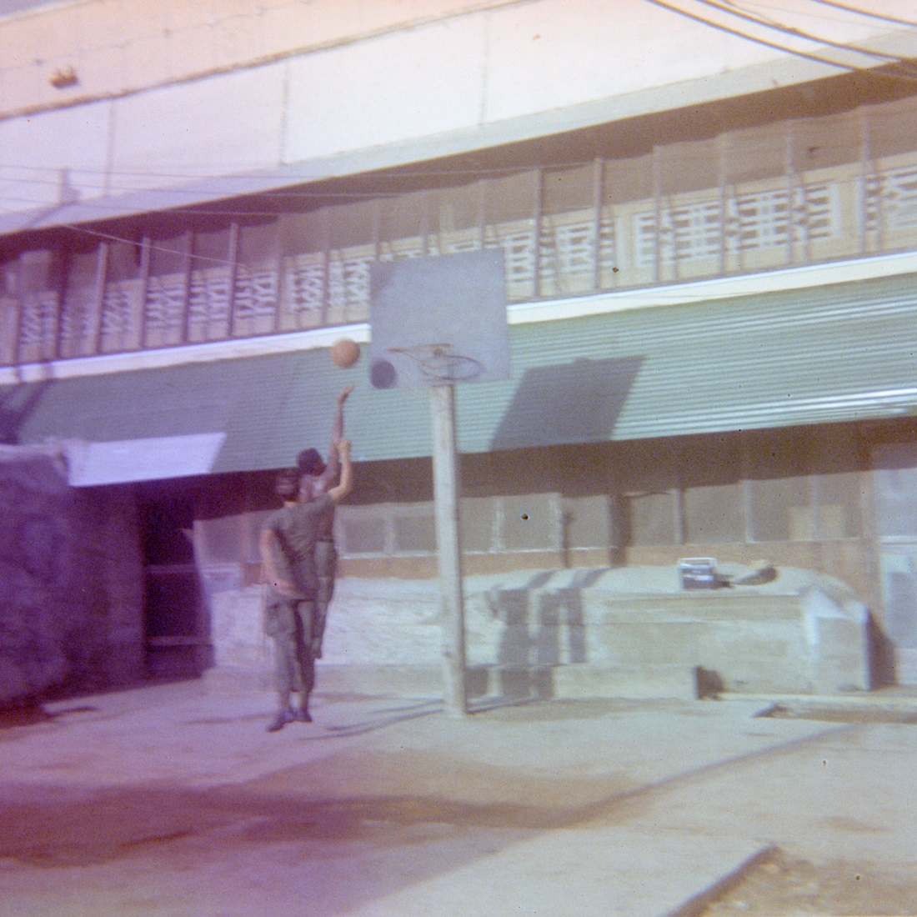
589027_20.jpg
The exterior of the “MP villa” and our basketball goal.
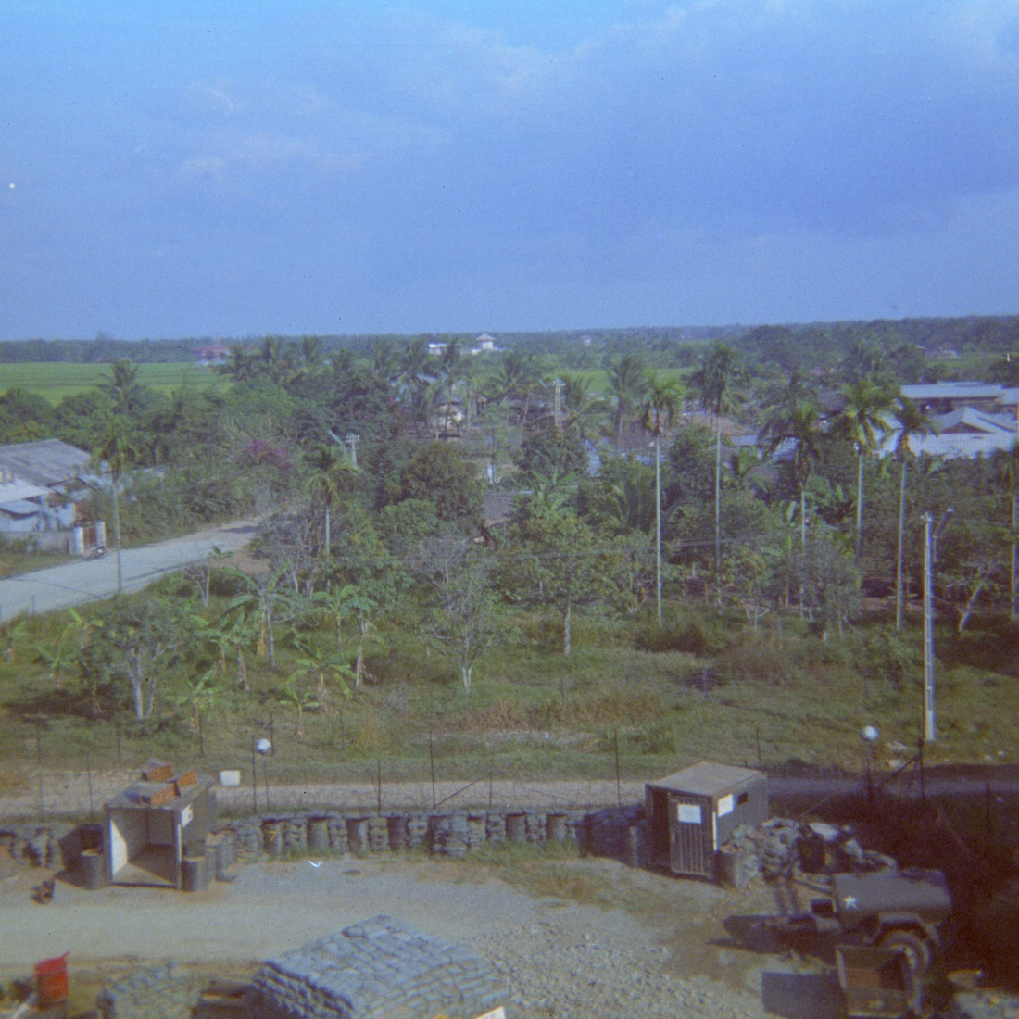
586959_5.jpg
View from the roof of the villa, toward the rice paddies to the east.
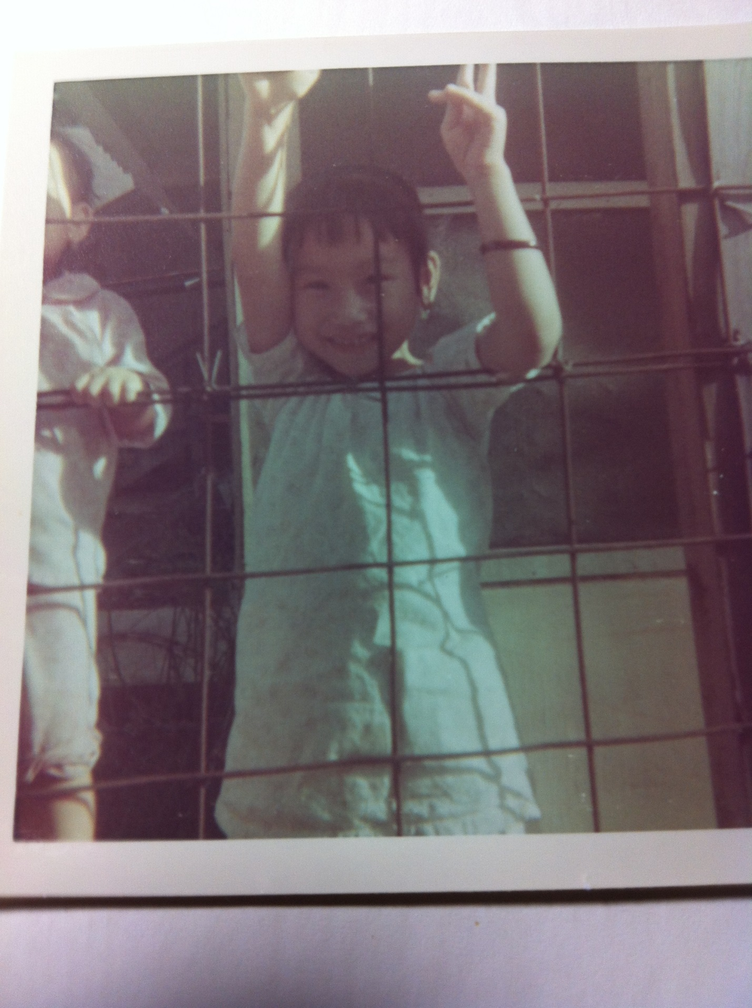
IMG 1812.JPG
Our lovely neighbors. There was an ARVN unit next door, and the children would greet us.

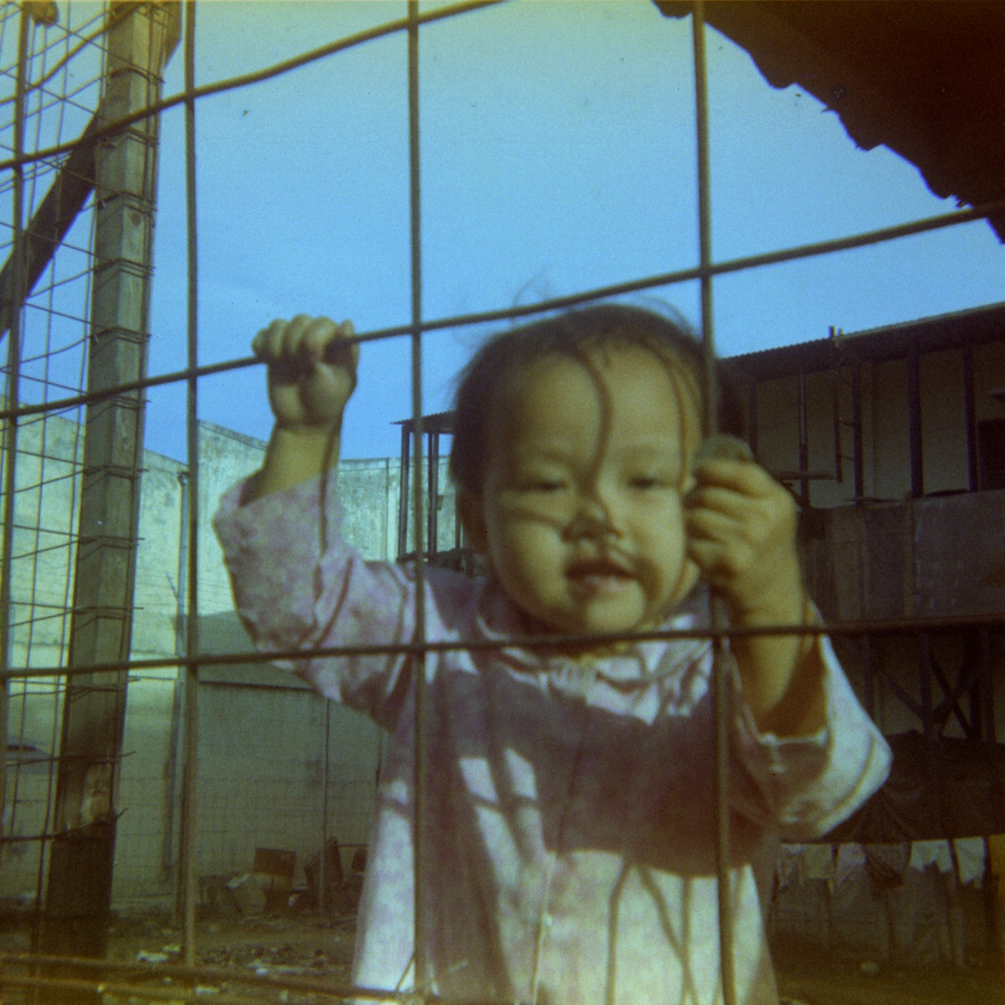
589027_14.jpg
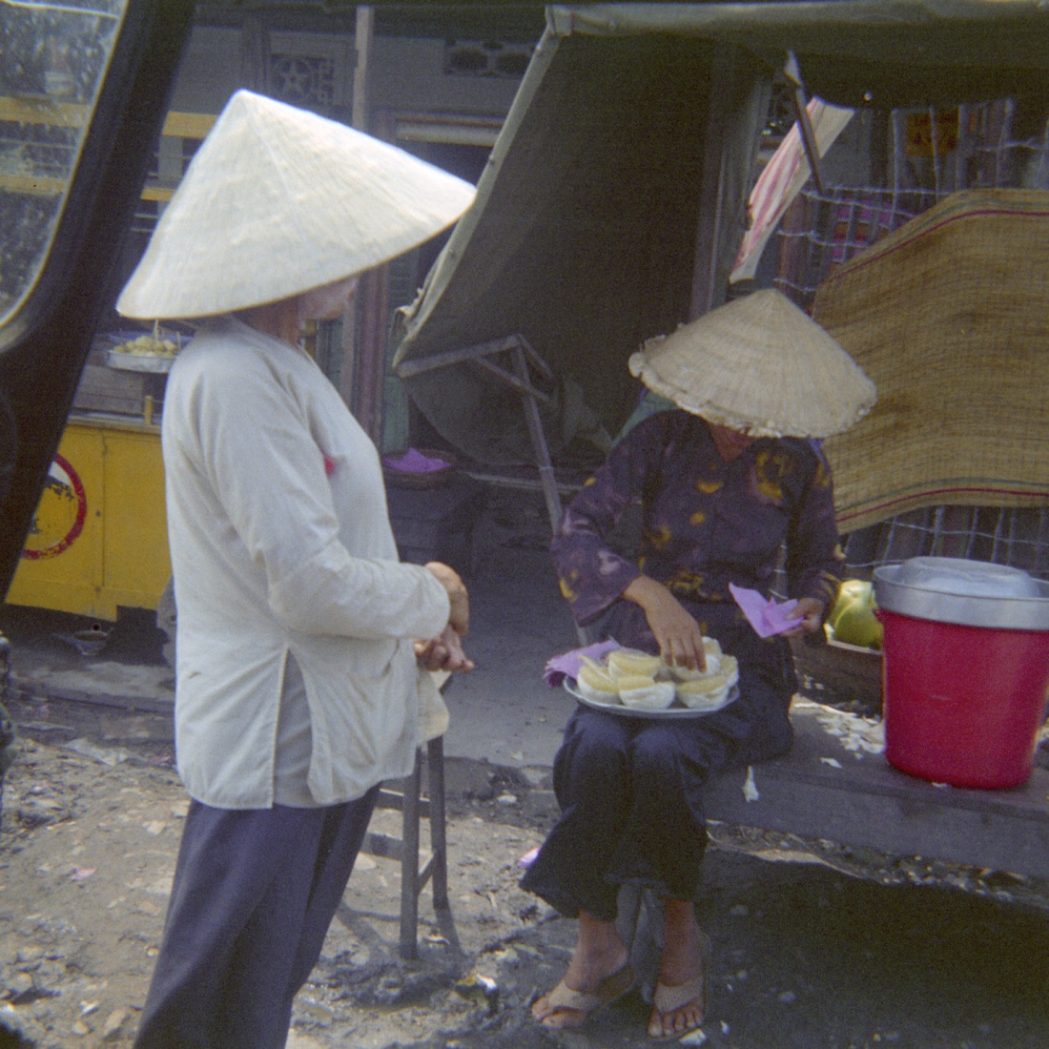
456651_8.jpg
Vendors at the My Thuan Ferry (if I remember correctly) on a branch of the Mekong River. In QL 4, the ferry is recast as the My Linh ferry and Vinh Long is replaced by Van Loc, to avoid having geographical limitations on the descriptions in the book.
A bridge, completed in 2000, has replaced the ferry. For more on this, see the website for SkyDoor Travel: http://en.skydoor.net/place/My_Thuan_Bridge.
Also, QL 4 is no longer. Instead, it is National Highway 1.

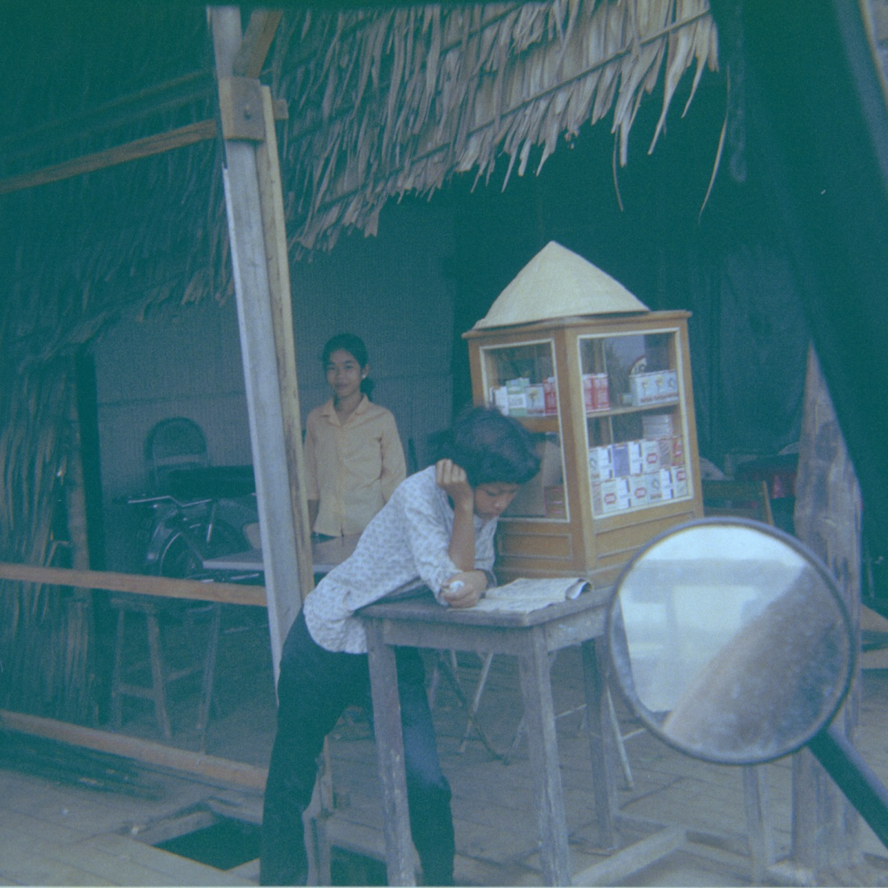
456651_4.jpg
More photos from the ferry, taken with a small Brownie Instamatic from an MP patrol jeep.
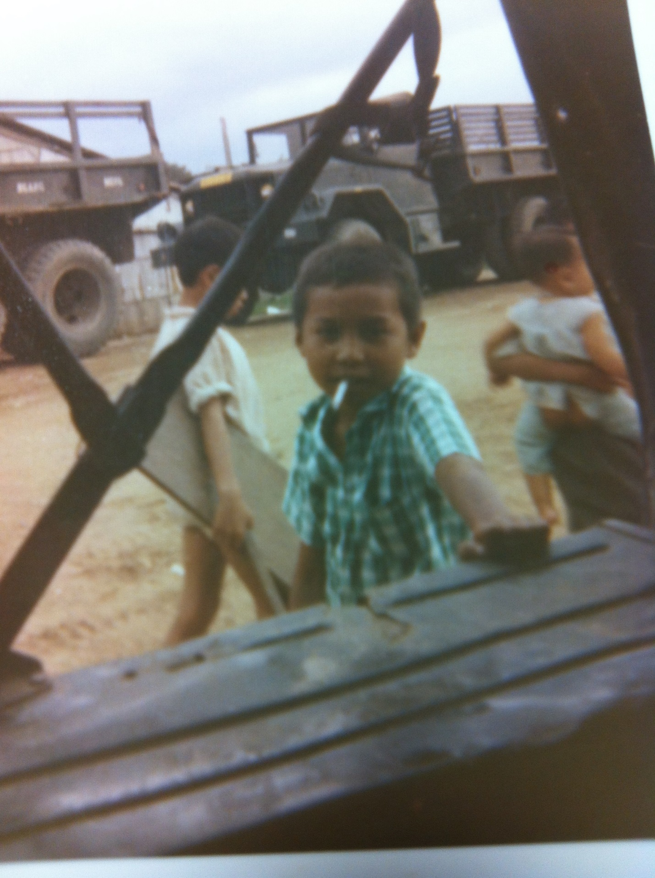
456651_15.jpg
Street toughs at the ferry, my guess about ten years old. It wasn’t unusual for one of them to tell you, “GI, tomorrow you die,” or some equally encouraging remark.

On the ferry—greeting the passengers. The MP relationship with the Vietnamese public was generally quite friendly, although there were some rough moments, some of which are described in QL 4. Unpleasant contacts included confrontations with Vietnamese soldiers (involving firearms and grenades) and terrible traffic accidents, such as the boysan being bisected by a deuce-and-a-half (a 2 ½ ton military cargo truck).
362770_11.jpg
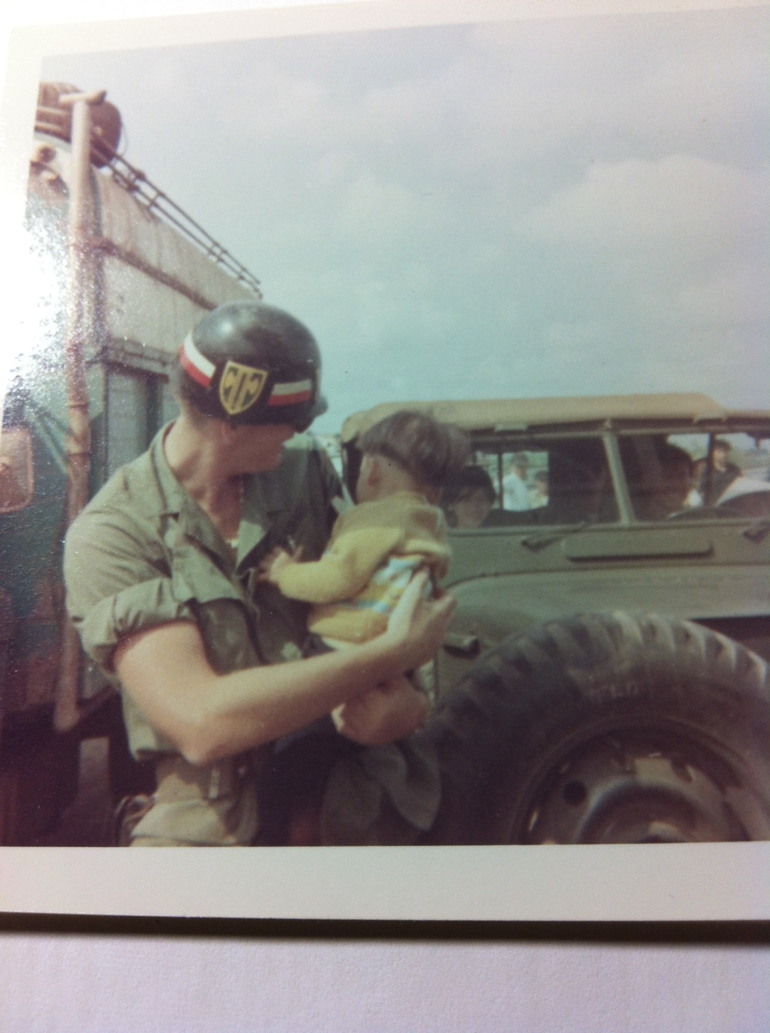
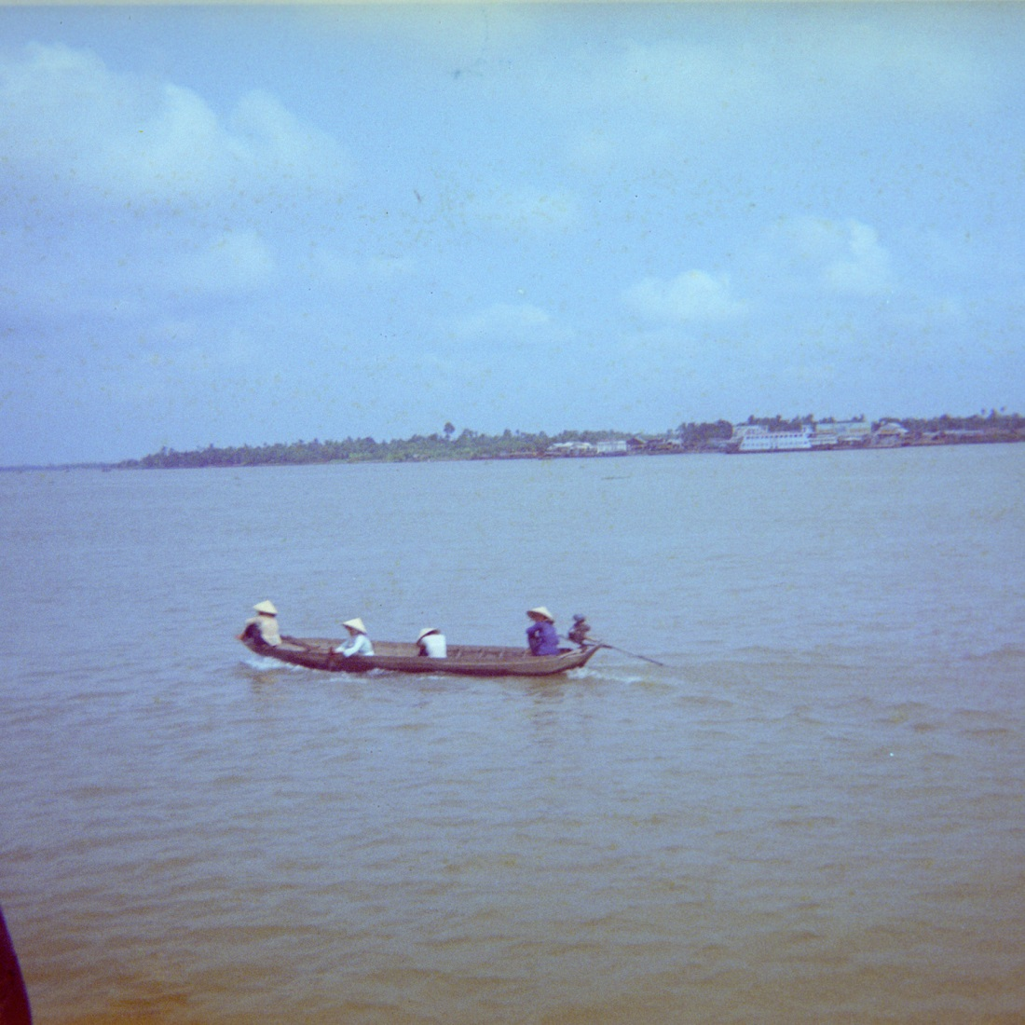
362770_12.jpg
Travel on the Mekong River, near Vinh Long.
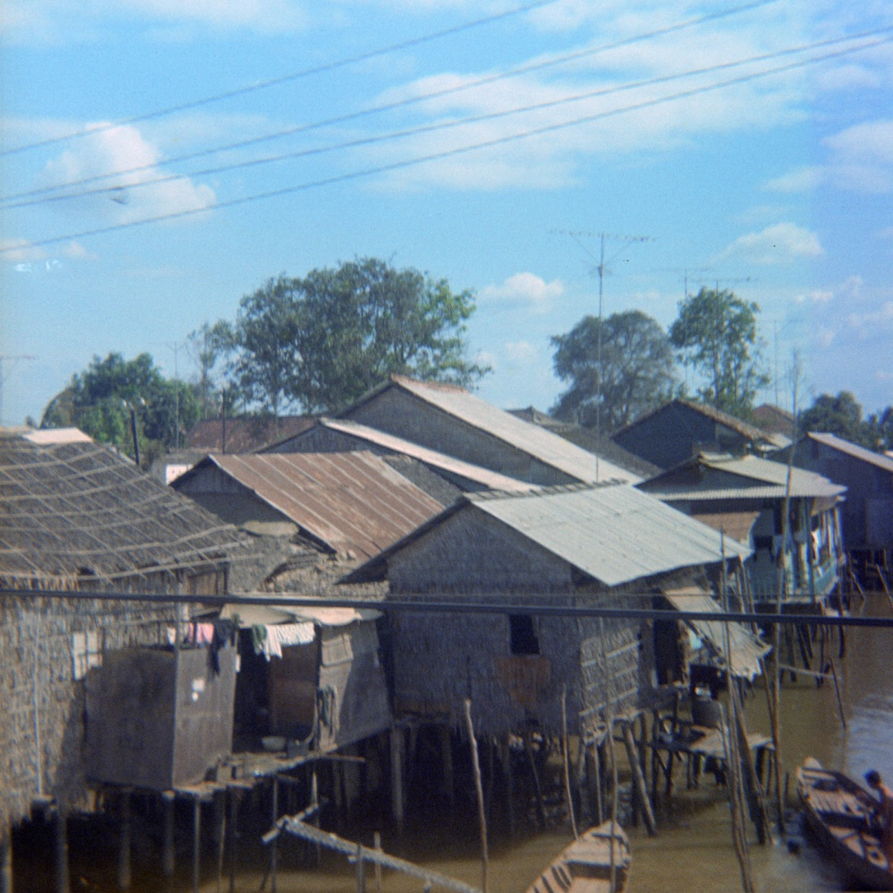
362770_1.jpg
Houses along a canal in Sa Dec, farther up the Mekong from Vinh Long. This photo was taken on a joint patrol with the Vietnamese National Police (“White Shirts”).

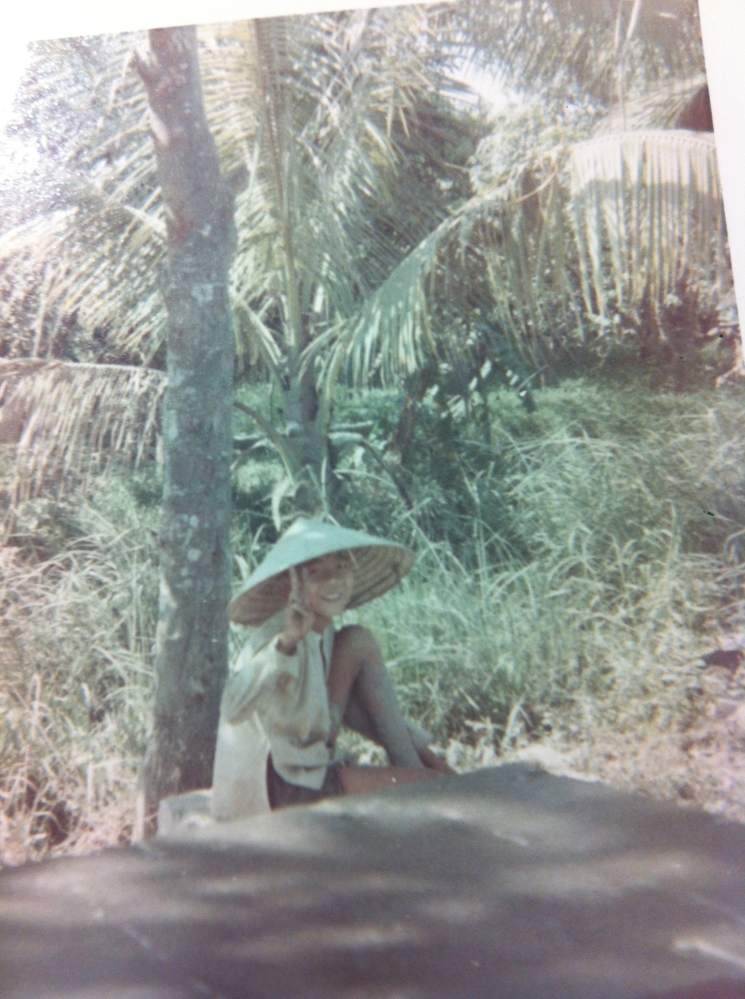
IMG 1816.JPG
Peace! We all felt the same.

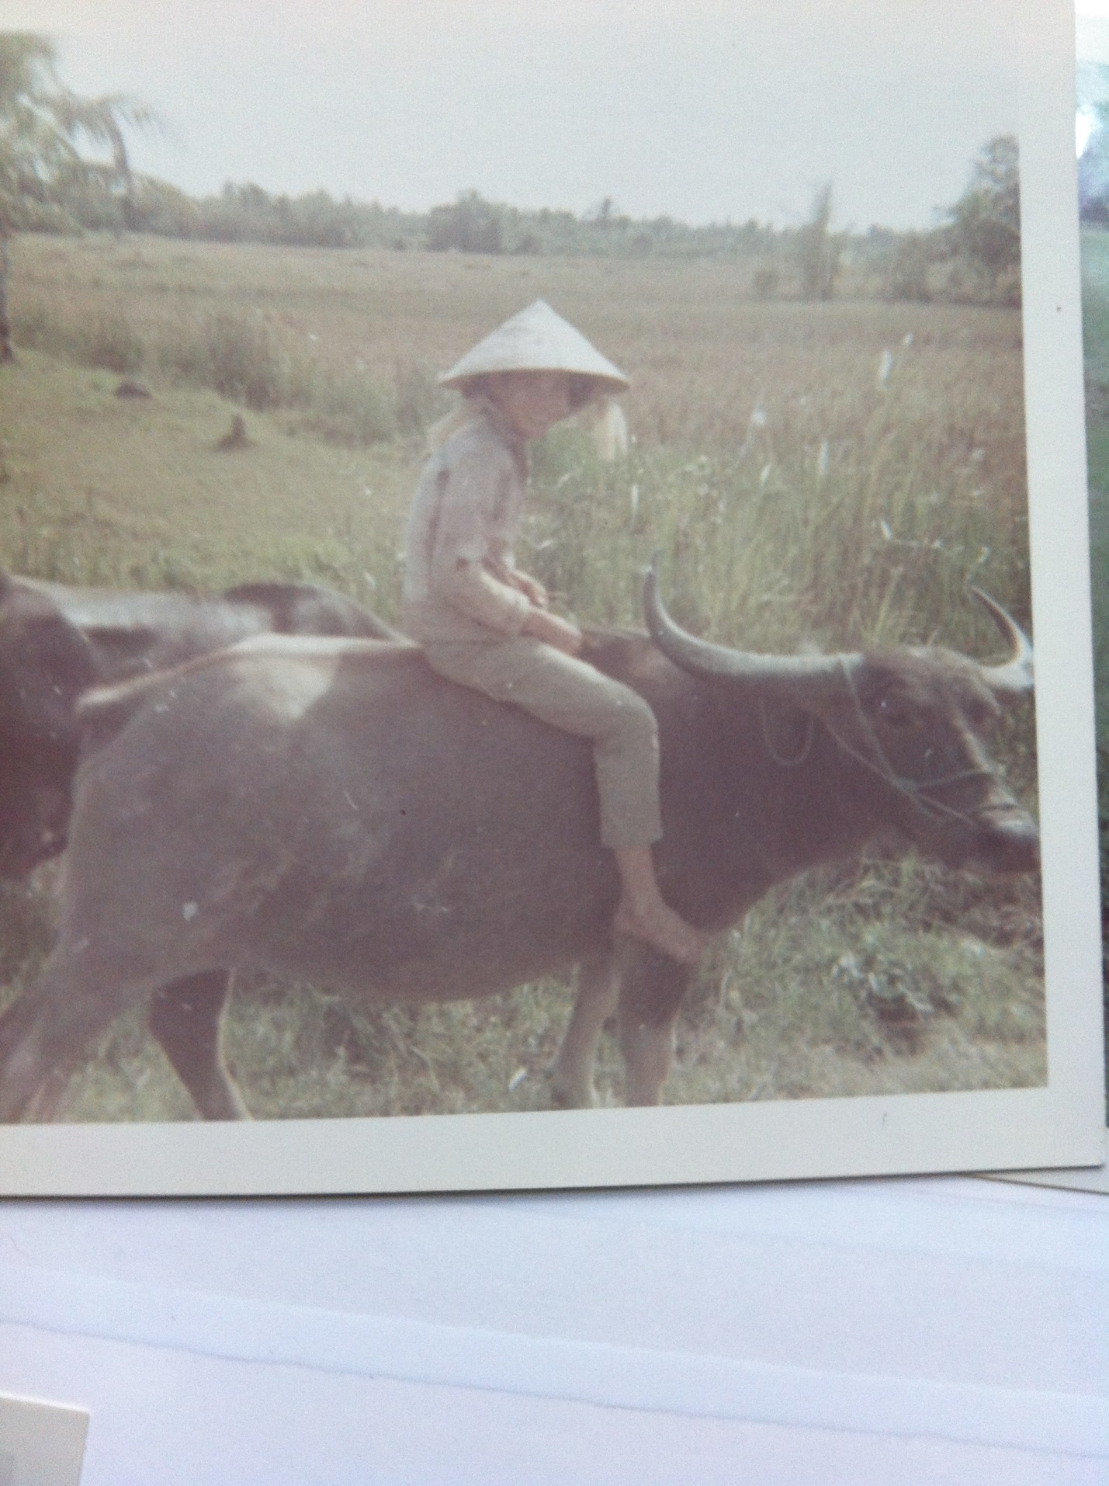
362770_5.jpg
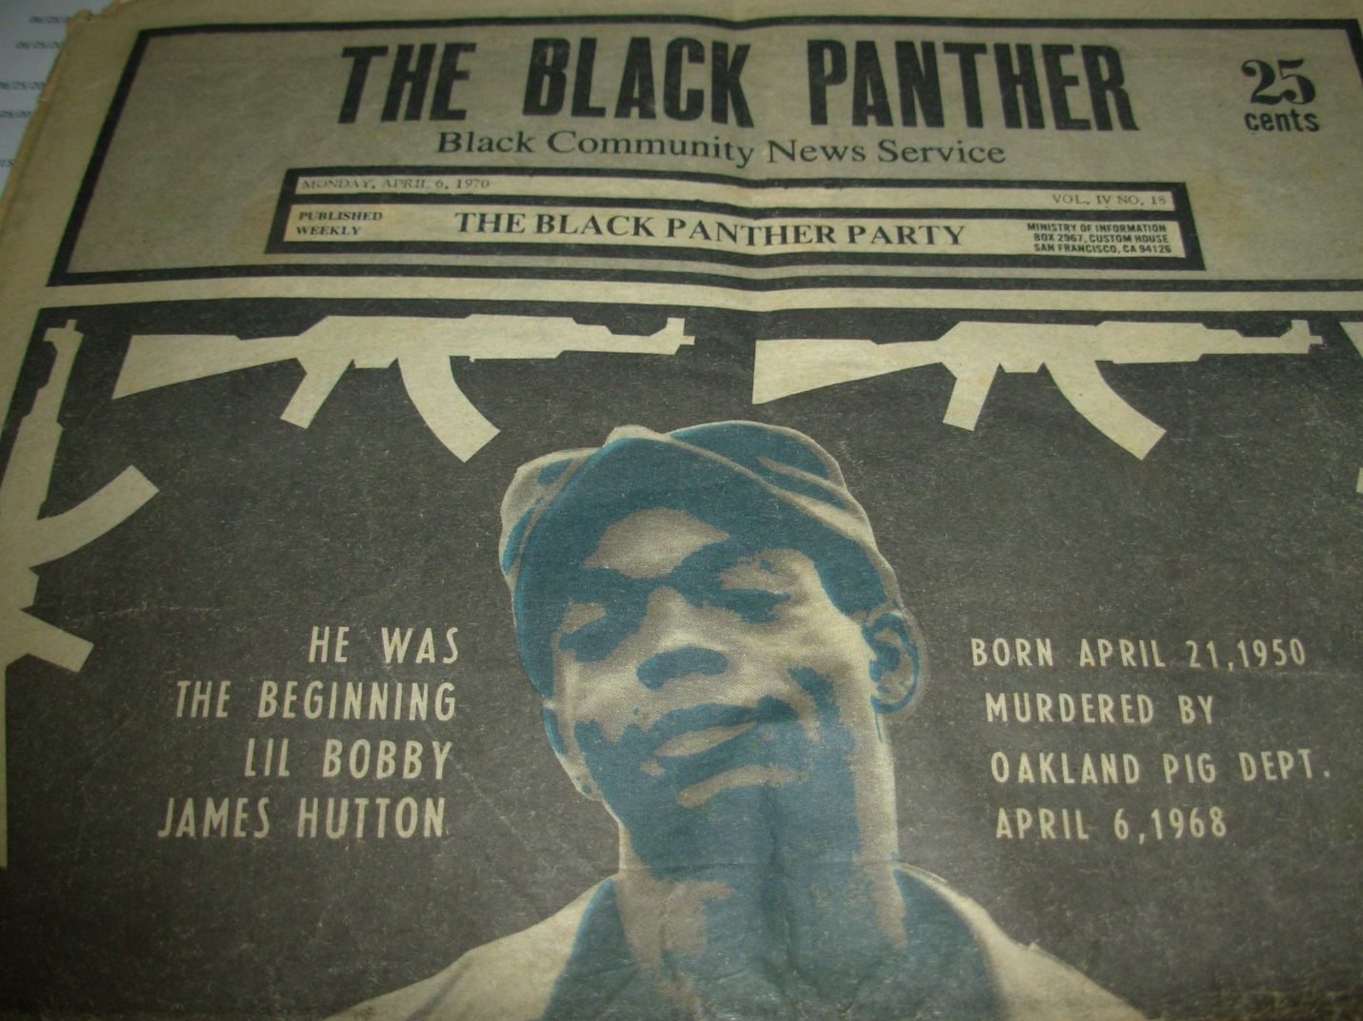
DSCN0155.jpg
A Black Panther newspaper that I brought home from Vietnam.
Racial tensions were high in 1970, both in the States and in Vietnam. Black soldiers viewed their oppression as exacerbated by being sent to fight in a war to keep the Vietnamese “free” when they did not have many basic freedoms at home. Slave bracelets and segregated cliques were common. The “race riot” in QL 4 is described pretty much as it happened, although there probably wasn’t the critical mass for a real “riot.” The author did witness a real riot while a law student at Duke the year before: phalanxes of police in riot gear, clouds of tear gas, and flying rocks. It made the front page of the New York Times (Feb. 14, 1969).

